# Problem 1

def testfunction(a=0):  
 try :  
 b = a/0  
  
 except ZeroDivisionError:  
 print("Cannot divide a number by Zero")  
  
  
  
a = input("Enter a number ")  
testfunction(int(a))

Output

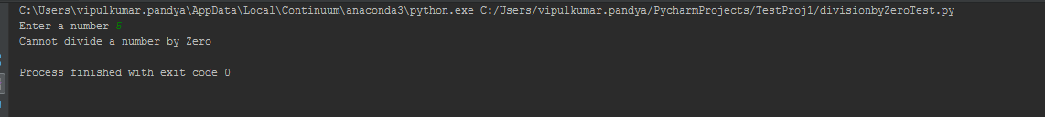

# Problem 2

subject=["Americans", "Indians"]  
verb=["play", "watch"]  
objects=["Baseball", "Cricket"]  
  
for i in subject:  
 for j in verb:  
 for k in objects:  
 print(i + " " + j + " " + k )

Output

